Assessment

Introduction to UX

|  |  |
| --- | --- |
| *Name* | Gabriel Lansberg |
| *Student number*  *Attempt* | 18133916  Module 1 |
| *Academic year* | 2017-2018 |

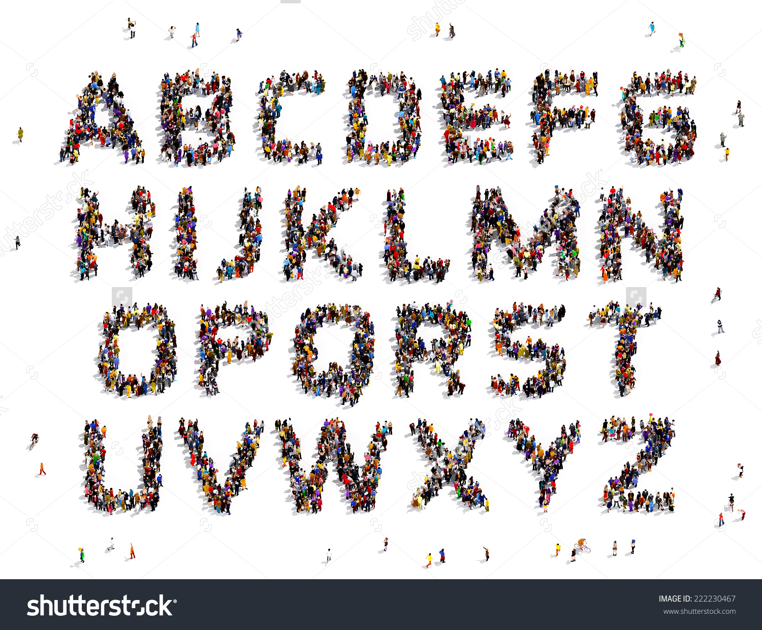

**USER EXPERIENCE DESIGN**



Faculty of IT & Design

Contents

1 Introduction 2

1.1 The product: STRAVA 2

1.2 The user: Sunday Athlete 3

1.3 The context: 4

2 Critiquing Usefulness 5

2.1 Usefulness of Strava 5

3 Critiquing Usability 6

3.1 Usability factor 1 Accessibility 6

3.2 Usability factor 2 Efficiency 6

3.3 Usability factor 3 Learnability 7

4 Critiquing Engagement 9

4.1 Engagement factor 1 Activation 9

4.2 Engagement factor 2 Authenticity 10

4.3 Engagement factor 3 Flow 10

5 Critiquing Meaning 12

5.1 Meaning factor Relatedness 12

6 Conclusions 12

6.1 Overall quality of the User Experience 12

6.2 Great UX design(ers) 13

7 Literature 13

# Introduction

## The product: STRAVA

### What is the purpose of this product for the user?

The company itself says that their name came from the Swedish word Strava, which means to strive forward. I believe that the purpose of the app is in the name, to make the users strive towards their dream.

### What are the functions and features the product offers to fulfil its purpose?

Strava is a social fitness network that is used to track: cycling, running, and swimming activities, using GPS data. Activities are recorded via the Strava mobile application, GPS-enabled fitness watches or cycling computers. Users can upload activities to the Strava site directly, via the Strava mobile application, or via one of Strava's data partners such as Garmin.

### How does the user interact with the product (and the system)?

The user interacts through the application or the Strava website. Everything is synced up to both platforms and user has access to them with their personal account. As mentioned beforehand, the user can sync all the third party accessories to the app and desktop version to get even more data from training sessions.

## The user: Sunday Athlete

### How would you describe a typical user of this product?

Because the app is catered for athletes, it is easy to say that the userbase is mainly athletic people. Someone who uses this app on a regular basis has to be active and always up and about.

### What (be, do, motor) goals does this user have related to the product?

The user goal for this app is to make tracking the training sessions as easy and quick as possible. After opening the app, you just have to press two keys and the user is ready to go and enjoy training. The user would rather be out the door and on their bike within minutes rather than longer.

### What are relevant characteristics of the user that influence how they use and experience the product? Explain how

The user who I’m using as an example lives in Copenhagen, he uses a bicycle for daily commuting. His name is Robert and I know him personally for over 4 years. He is an avid fixed gear cyclist and his daily commutes usually are almost 50 km long and if he has time left in the day, he takes an extra ride in the evening. He owns 3 different fixies, 2 mountain bikes and a road bike. Every time I see him, he has his bike with him and has bike shoes on. He is the typical user for the app. More active than the regular person but not a full-time athlete.

## The context:

### In what situations (use DETAILS) would the user use this product?

Strava is most handy while training. It was made with the purpose of keeping track of your training and your friends. So the main times a user use Strava are: before/while/after training, commuting, looking at friends current stats, compering the leaderboards, taking part of a competition and joining a challenge.

Almost every reason is tied to training.

### What characteristics of the context influence the user experience? Explain how

Strava really prevails in making the user feel good after the training session. The key for the feeling is how Strava shows you your achievements that you accomplished while training. For example:



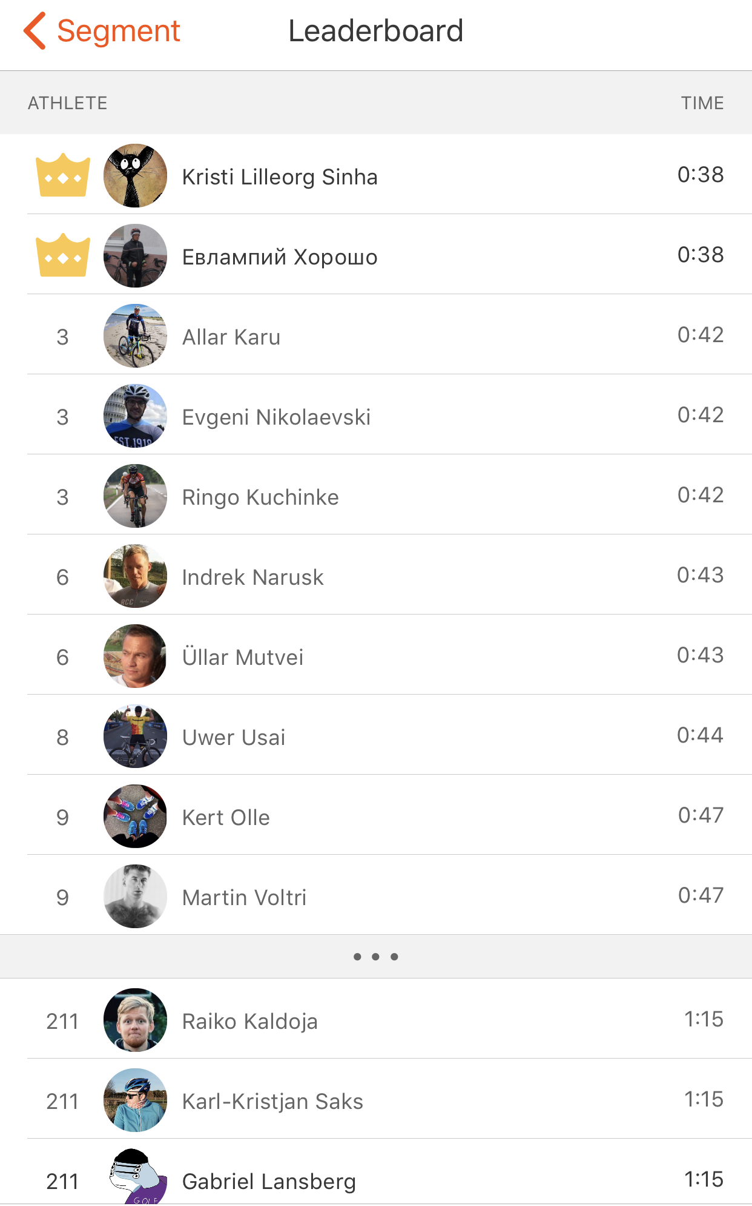This is one of my personal records in crossing a big bridge in Tallinn. While the user sees that they made a new personal record, they can access other people’s records and times as well. Whenever someone is tracking their ride on that length of road it will time it and put it in the leaderboard

# Critiquing Usefulness

## Usefulness of Strava

**How well does the product fulfil its purpose?**

As mentioned, many times already the main purpose of the app is to follow users training stats via mobile app. Strava is accurate and precise with marginal error. Still data connection is needed.

**[](https://www.google.nl/url?sa=i&rct=j&q=&esrc=s&source=images&cd=&cad=rja&uact=8&ved=0ahUKEwjPt5-rmt7UAhWNb1AKHffNDCMQjRwIBw&url=https://phys.org/news/2016-12-recommendingthree-internet-age.html&psig=AFQjCNEyni3tIhLq0xlW7-SYP5mD4BkMsg&ust=1498658980945790)**

### Explain your rating referring to the user needs

I rate Strava 5/5 for fulfilling its purpose. The reason being easy, it does what it says it is going to do. Starting your workout with two taps is very convenient for the user for maximizing the workout not the interaction with the app.

### In what situation is the product most useful for the user? Explain

The app is most useful before and after the workout. It can have many different insights from the training sessions. The information gathered from that can further help the users future training sessions and make the users training more fruitful and better.

# Critiquing Usability

## Usability factor 1 Accessibility

### How do you explain this usability factor (in general) to others?

Accessibility is the quality of being easy to obtain or use.

**How do you rate your product on this factor? (circle a star)**

**[](https://www.google.nl/url?sa=i&rct=j&q=&esrc=s&source=images&cd=&cad=rja&uact=8&ved=0ahUKEwjPt5-rmt7UAhWNb1AKHffNDCMQjRwIBw&url=https://phys.org/news/2016-12-recommendingthree-internet-age.html&psig=AFQjCNEyni3tIhLq0xlW7-SYP5mD4BkMsg&ust=1498658980945790)**

### Explain your rating using product, user and context characteristics

I would say that Strava is very accessible service. Strava exists as a website and is also available for IOS and for Android. This means that according to the user they can find the most accessible and most convenient way for using this service.

After finding the most accessible way for the Strava user only has to make an account to start using it. After that the user has freedom to use the service as they please. To access all of the content the user has to pay 5 dollars a month. This means that the user accesses: perks for partner firms, training videos, heatmaps, free entries for races, extra safety measures and so on. In my eyes for someone who uses this app on a regular basis that is not a lot to pay, considering everything that the 5 dollars extra offers.

Just to reiterate that these extra perks do not mean that the app falls short. Quite the opposite, comparing Strava to their competitors, Strava offers a lot more to the free user than the others.

## Usability factor 2 Efficiency

### How do you explain this usability factor (in general) to others?

Efficiency is accomplishing something with the least waste of time and effort.

**How do you rate your product on this factor? (circle a star)**

### [Afbeeldingsresultaat voor rating](https://www.google.nl/url?sa=i&rct=j&q=&esrc=s&source=images&cd=&cad=rja&uact=8&ved=0ahUKEwjPt5-rmt7UAhWNb1AKHffNDCMQjRwIBw&url=https://phys.org/news/2016-12-recommendingthree-internet-age.html&psig=AFQjCNEyni3tIhLq0xlW7-SYP5mD4BkMsg&ust=1498658980945790)

### A screenshot of a cell phone Description automatically generatedExplain your rating using product, user and context characteristics

Strava does not waste unnecessary time or effort. Starting the recording of a workout is easy and achievable by only 2 clicks and takes maximum 3-10 seconds. While working out the app does everything by itself and does not need any input from the user at all if in default settings. User can choose to have even audio cues if needed. It provides information about average pace and distance to the user. After the workout user has to end the tracking with 2 clicks once more, confirming that the user really wants to end the tracking. And after that the user lands on the “Save activity” (seen under the paragraph). Filling that out can take 1 second and it can take 1 hour depending on the user. After that users training session is saved to their activity page and shared on the feed.

## Usability factor 3 Learnability

### How do you explain this usability factor (in general) to others?

Learnability is the capability of a software product to enable the user to learn how to use it.

**How do you rate your product on this factor? (circle a star)**

**[](https://www.google.nl/url?sa=i&rct=j&q=&esrc=s&source=images&cd=&cad=rja&uact=8&ved=0ahUKEwjPt5-rmt7UAhWNb1AKHffNDCMQjRwIBw&url=https://phys.org/news/2016-12-recommendingthree-internet-age.html&psig=AFQjCNEyni3tIhLq0xlW7-SYP5mD4BkMsg&ust=1498658980945790)**

### Explain your rating using product, user and context characteristics

So, in my experience Strava is a learnable app. When first started up the app. Shows some basic ways of navigation. Then it shows how tracking of a workout is possible and how to use the recording. After that the user is left at their own mercy to learn the app with no additional info presented. Although the tutorials are somewhat vague, they do their job and Strava provides support on their website. I’m going to talk about it later, but the flow of the app helps to understand everything pretty quickly. These are screenshots of all the tutorials:

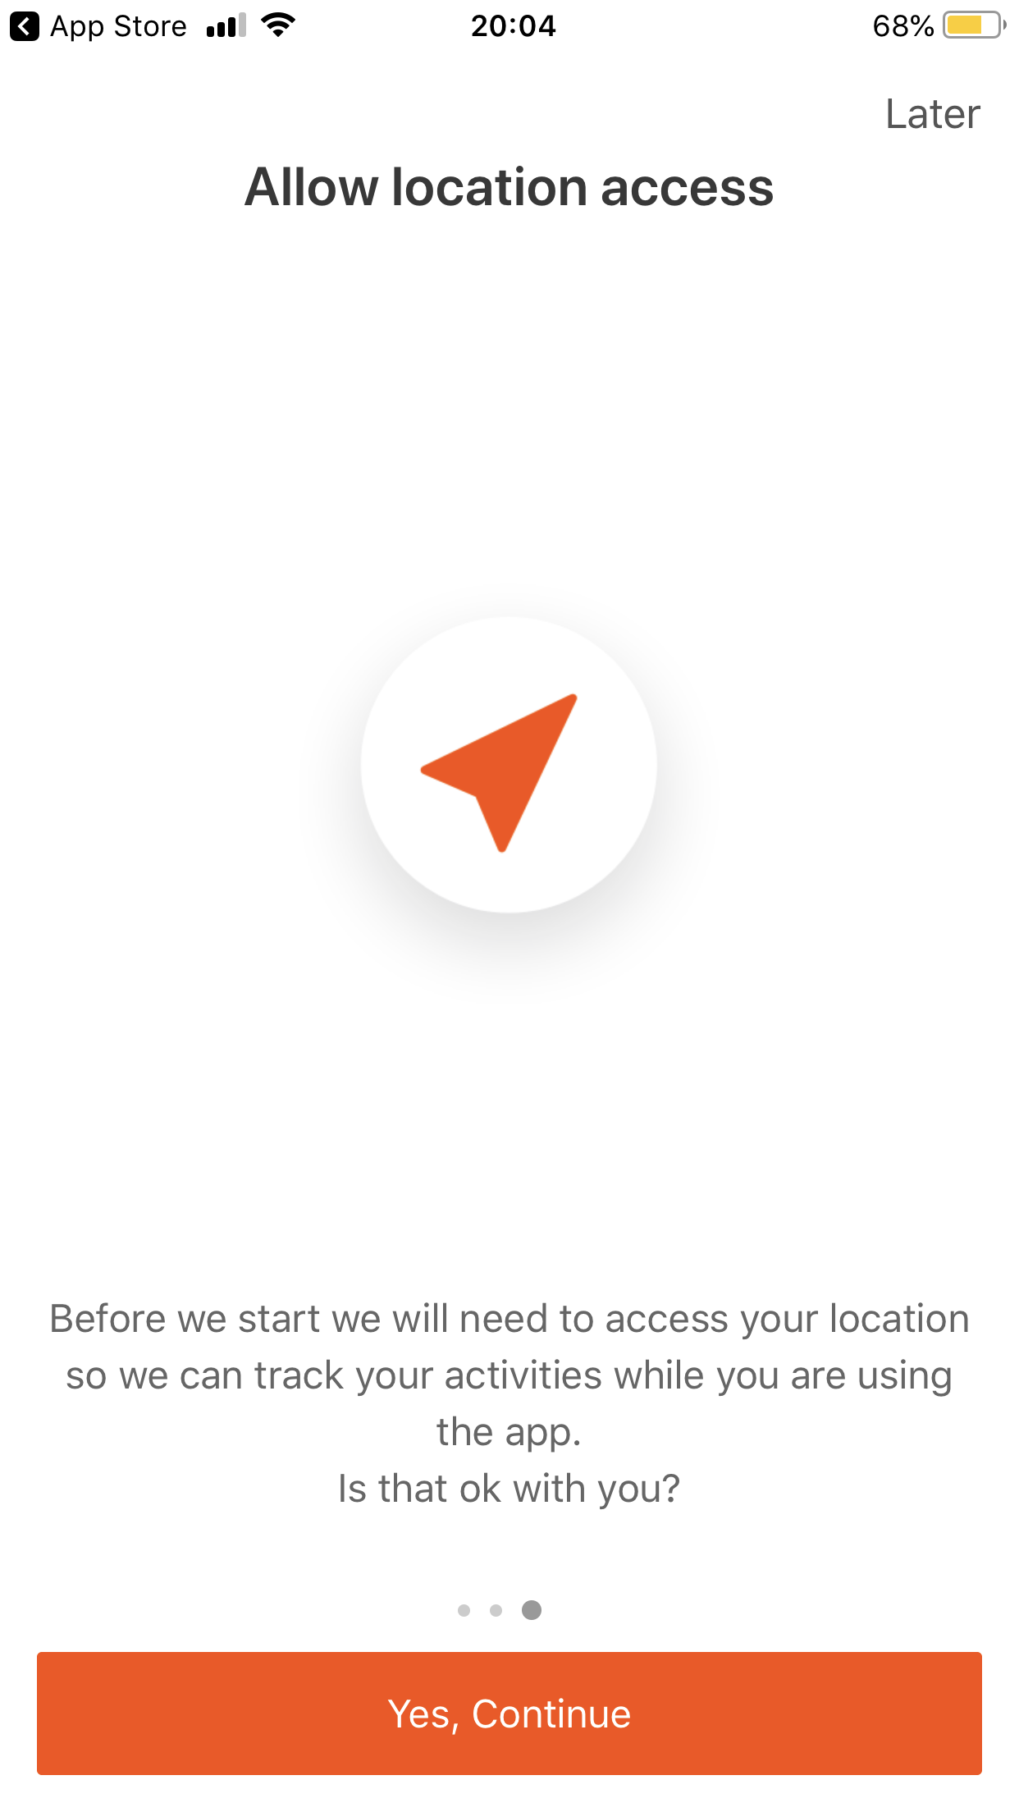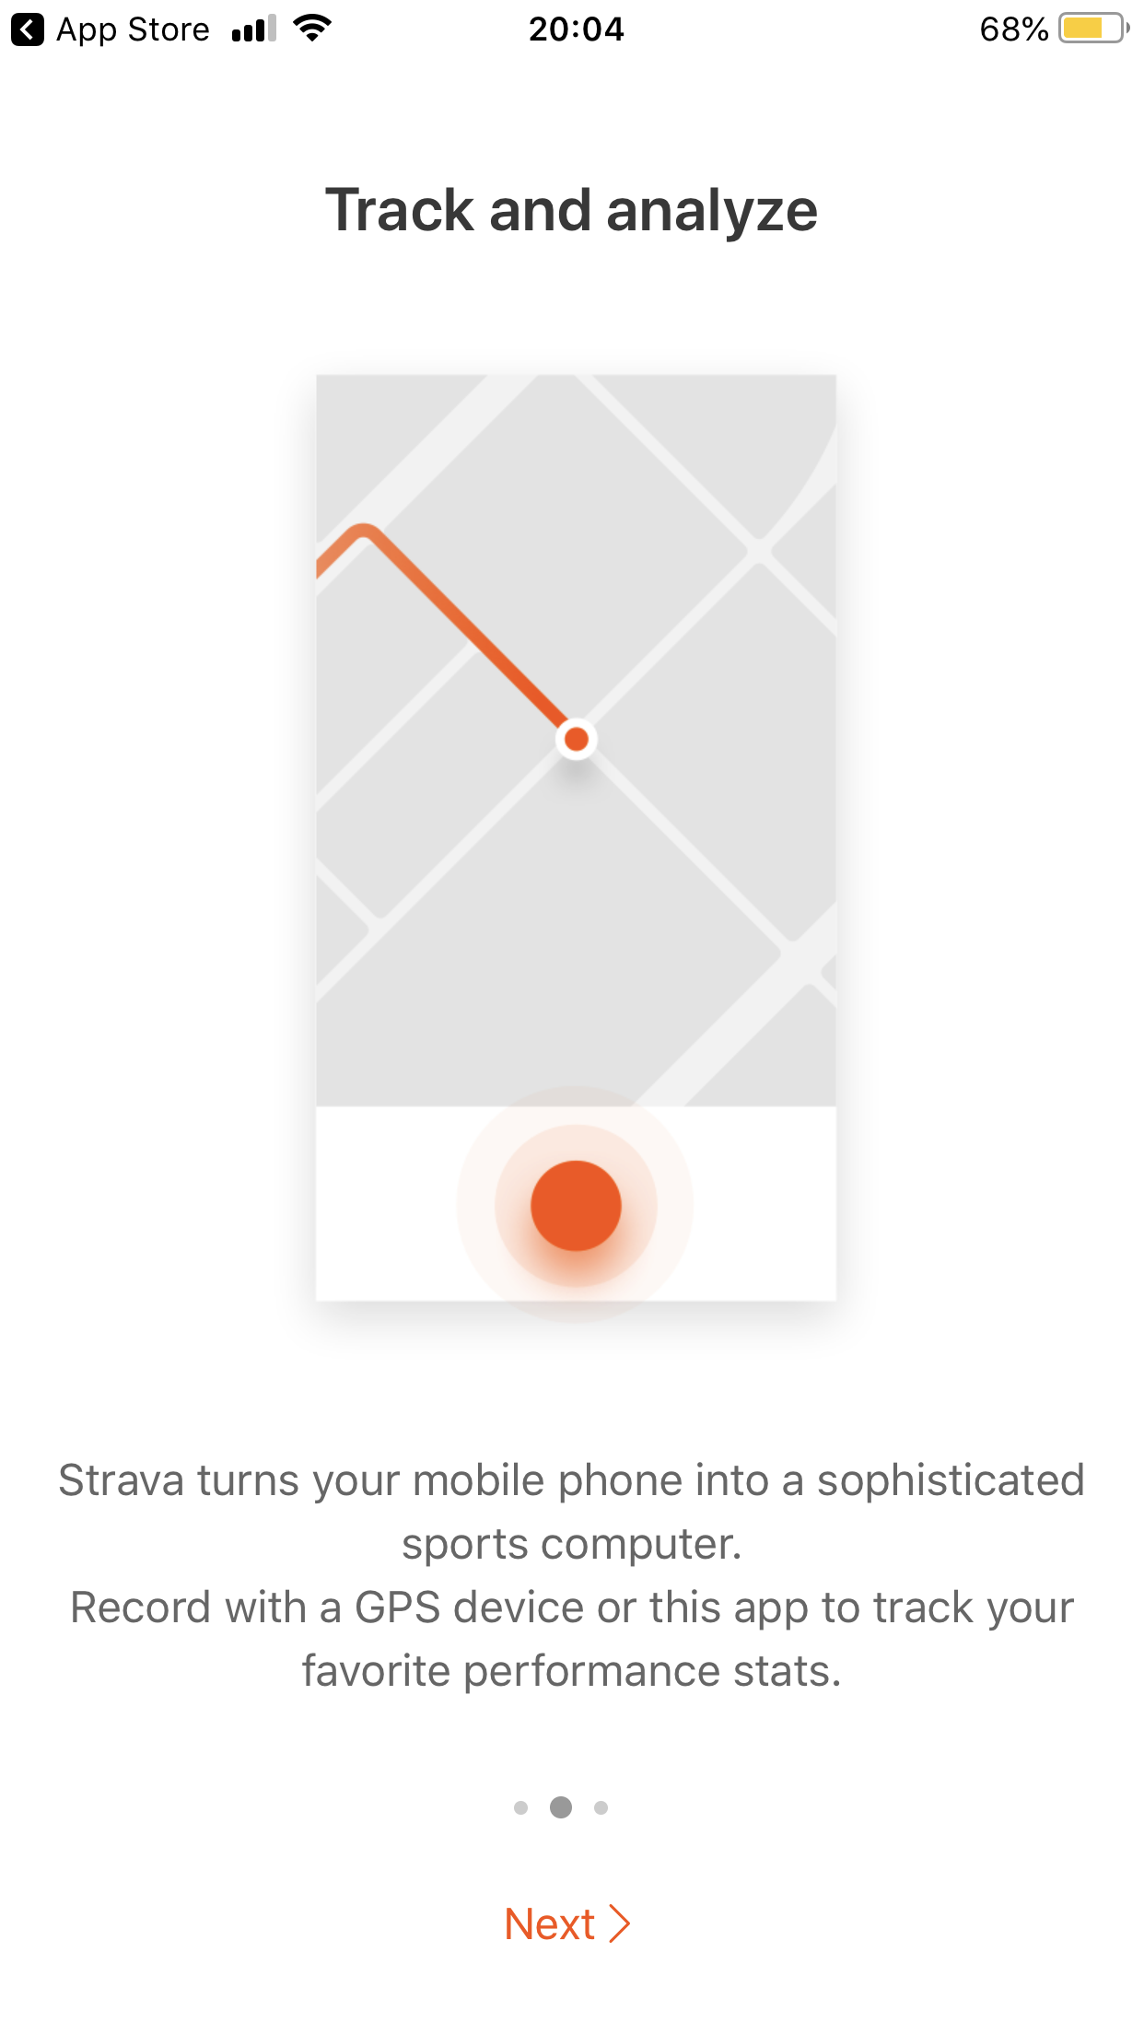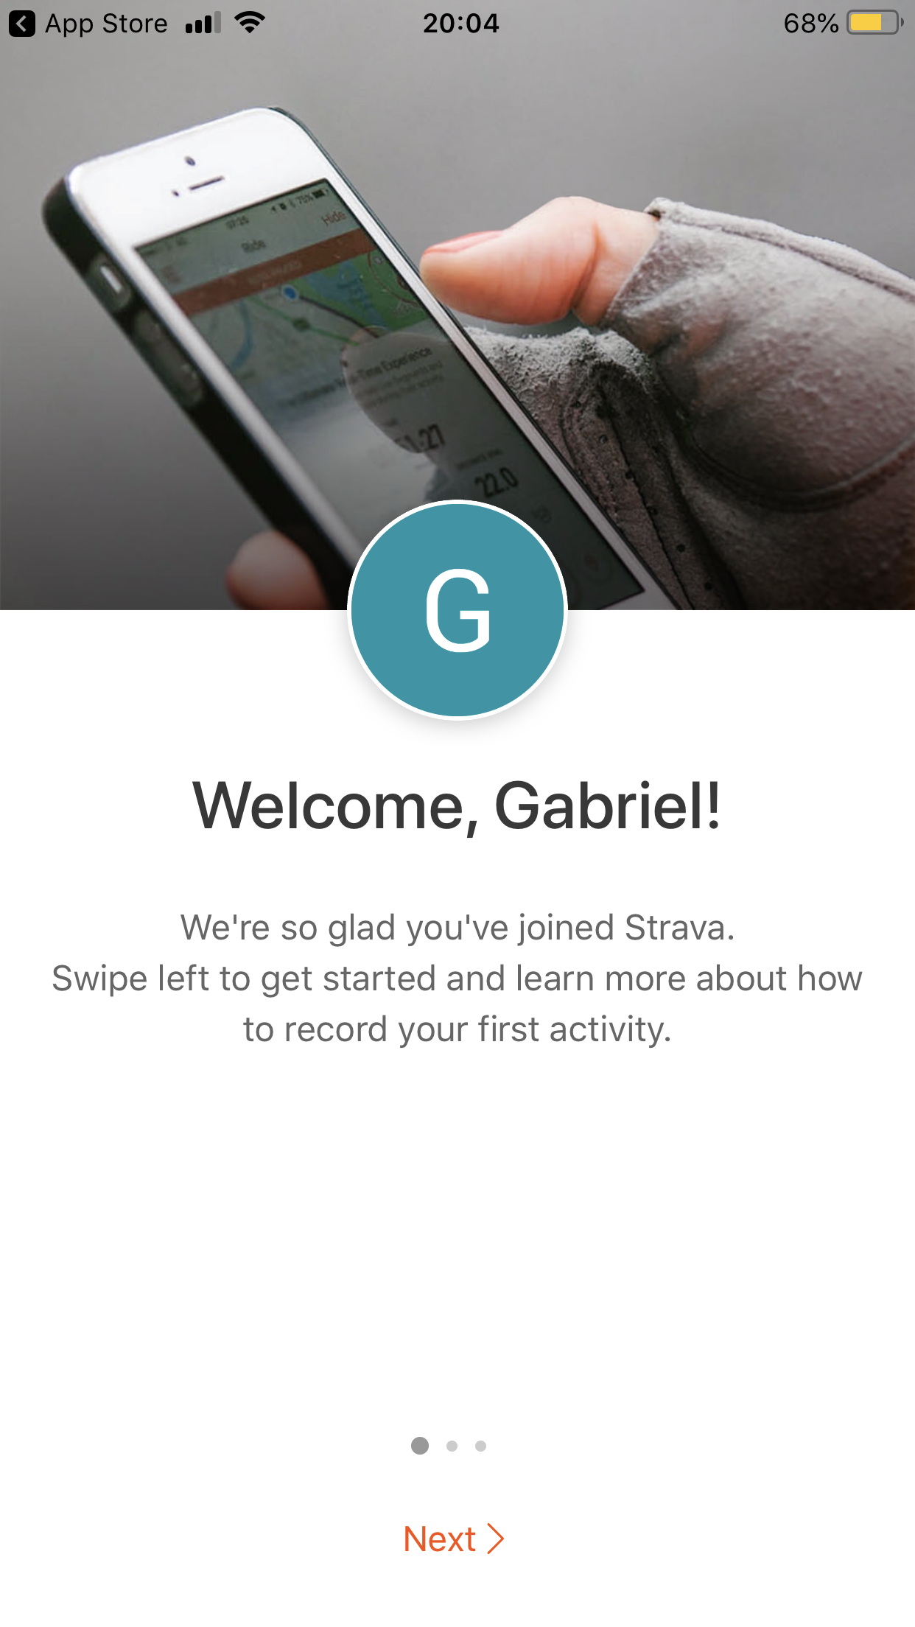

.

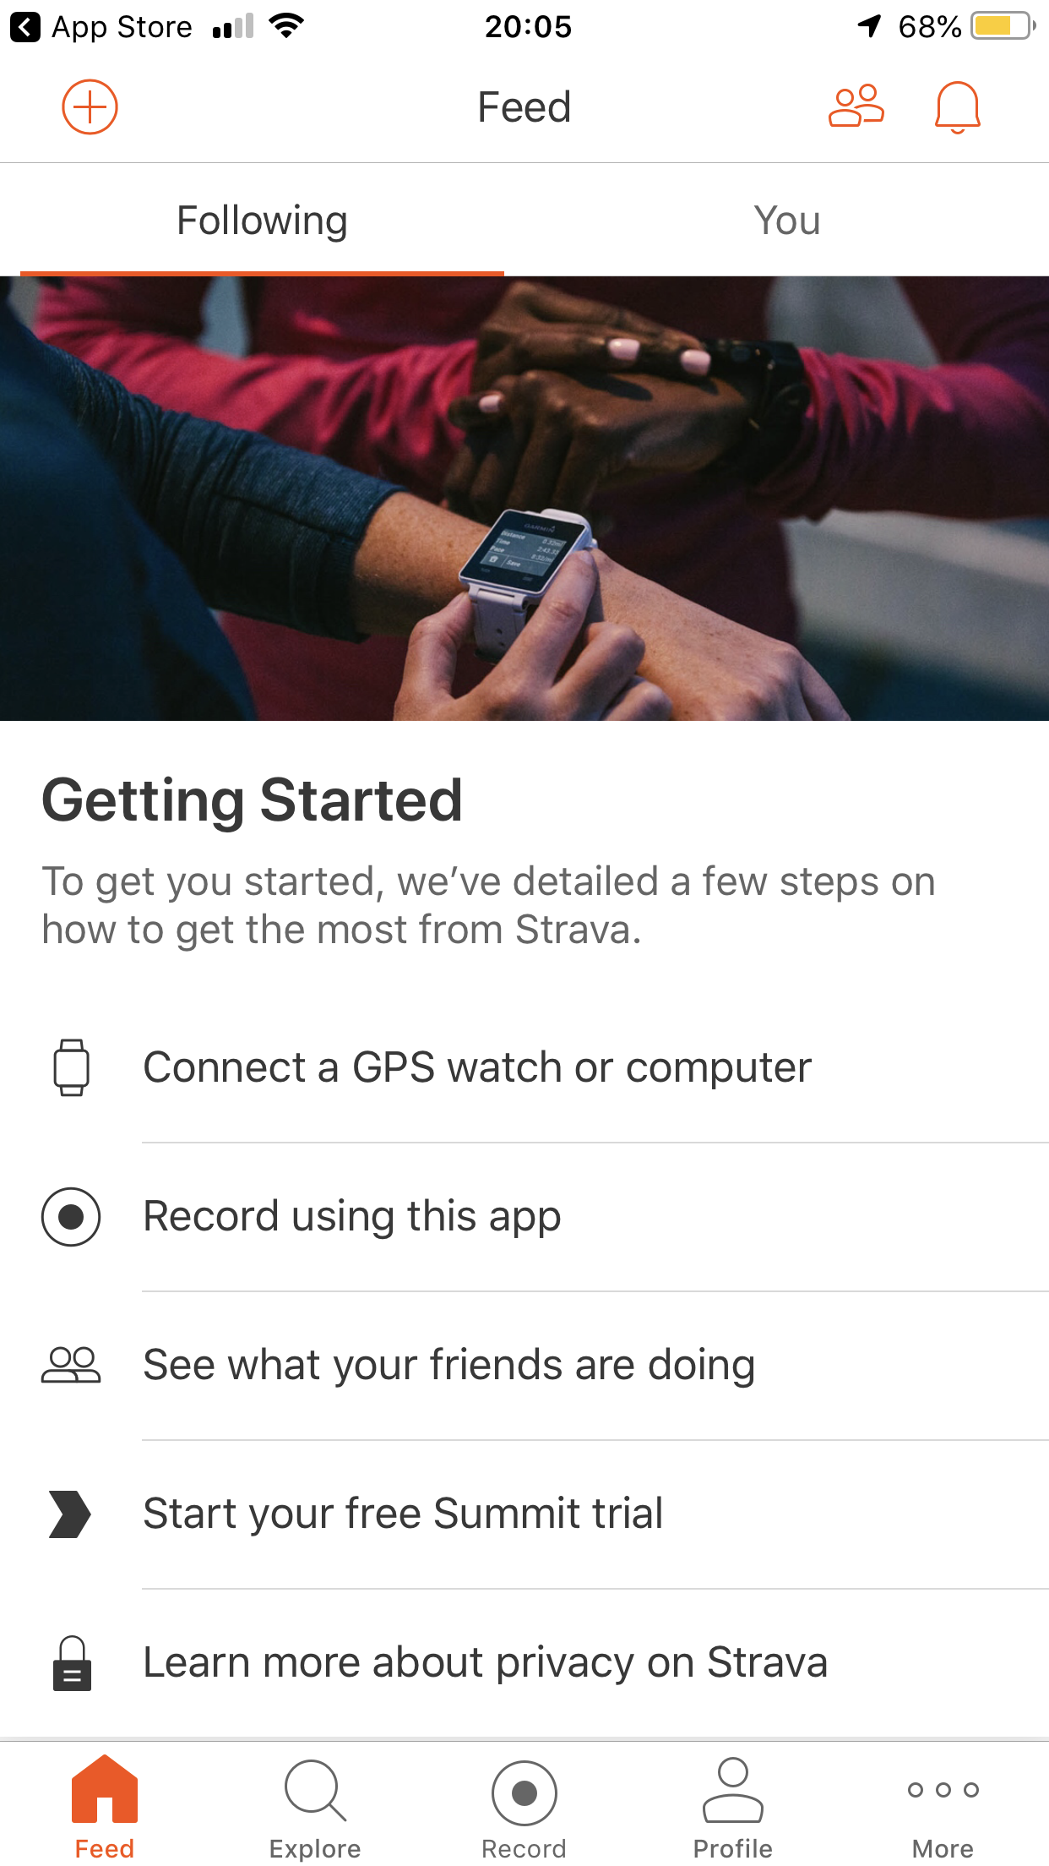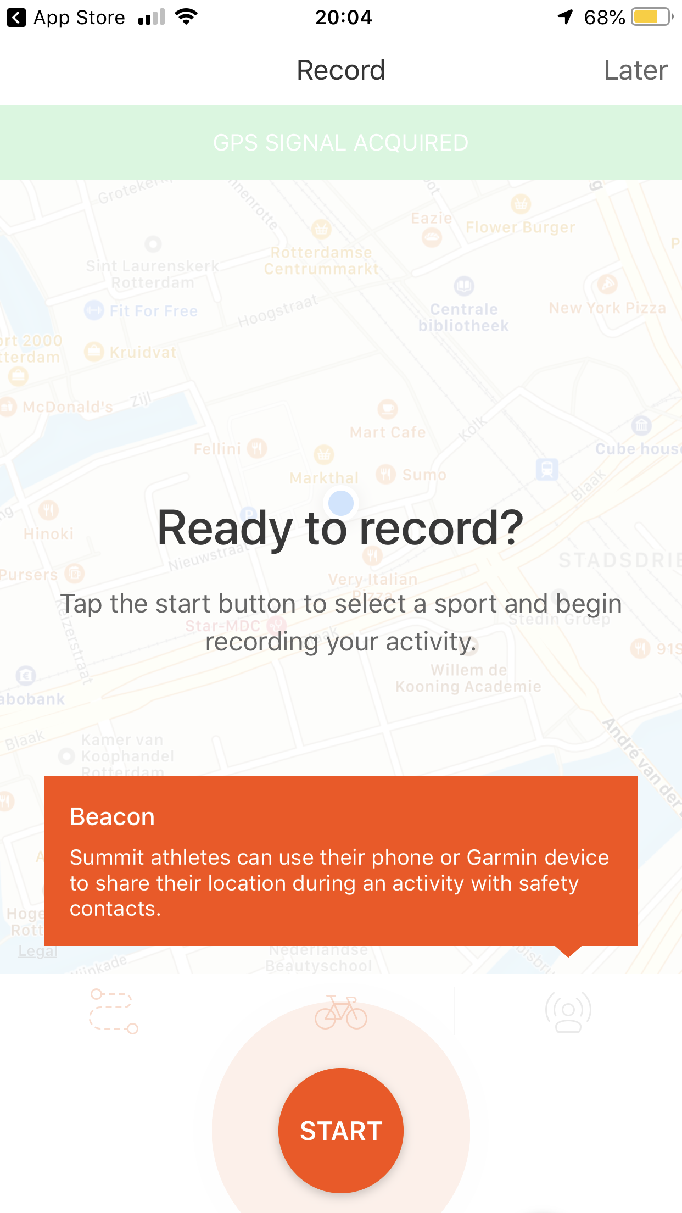

Pictures are provided in the order that they show when first starting up the app

# Critiquing Engagement

## Engagement factor 1 Activation

### How do you explain this engagement factor (in general) to others?

Activation means the action or process of making something active or operative.

**How do you rate your product on this factor? (circle a star)**

### [Afbeeldingsresultaat voor rating](https://www.google.nl/url?sa=i&rct=j&q=&esrc=s&source=images&cd=&cad=rja&uact=8&ved=0ahUKEwjPt5-rmt7UAhWNb1AKHffNDCMQjRwIBw&url=https://phys.org/news/2016-12-recommendingthree-internet-age.html&psig=AFQjCNEyni3tIhLq0xlW7-SYP5mD4BkMsg&ust=1498658980945790)

**Explain your rating using product, user and context characteristics**

Activation in this case would be the activation of the user. Looking at the app and how it is built, it is safe to say that activation is one of the main components what developers took into consideration. The apps social media part is built like Instagram, meaning that the users followers can give “kudos” under every workout. These “kudos” are basically likes towards the user. All of those likes from other peers usually manufacture a feeling of accomplishment. That feeling of accomplishment turns into motivation for the next training and one after that.

While the user explores the app even more thoroughly, they might stumble on challenges and clubs. The challenges are fun and very competitive. For example, someone posts a challenge: “Who can ride the furthest in a month?”. Then people who are interested join the challenge and start recording their rides for that challenge. All of the people competing are put into a leaderboard based on their distance. When people join a challenge, the app starts to send the user notifications to remind the user to work out. The notifications themselves can be controlled by the user. Leading to activation.

## Engagement factor 2 Authenticity

### How do you explain this engagement factor (in general) to others?

Authenticity is the quality of being authentic.

**How do you rate your product on this factor? (circle a star)**

**[](https://www.google.nl/url?sa=i&rct=j&q=&esrc=s&source=images&cd=&cad=rja&uact=8&ved=0ahUKEwjPt5-rmt7UAhWNb1AKHffNDCMQjRwIBw&url=https://phys.org/news/2016-12-recommendingthree-internet-age.html&psig=AFQjCNEyni3tIhLq0xlW7-SYP5mD4BkMsg&ust=1498658980945790)**

**Explain your rating using product, user and context characteristics**

The authenticity of this app is 5/5. I rate 5/5 only because there has been tracking apps on the market for ages each as good as the other. But Strava is more than just a workout tracking app. It’s a social media platform too. This gives the app a new vibe and makes it to a community too. The Strava community is something that any of the other tracking services don’t have and did not think of.

## Engagement factor 3 Flow

### How do you explain this engagement factor (in general) to others?

Definition of flow is to go from one place to another in a steady stream.

**How do you rate your product on this factor? (circle a star)**

**[](https://www.google.nl/url?sa=i&rct=j&q=&esrc=s&source=images&cd=&cad=rja&uact=8&ved=0ahUKEwjPt5-rmt7UAhWNb1AKHffNDCMQjRwIBw&url=https://phys.org/news/2016-12-recommendingthree-internet-age.html&psig=AFQjCNEyni3tIhLq0xlW7-SYP5mD4BkMsg&ust=1498658980945790)**

**Explain your rating using product, user and context characteristics**

Strava feels very sectioned and not like a whole. At the bottom of the screen are 5 different buttons: Feed, challenges, record, profile, more. That seems very sectioned and weird to me.

In my opinion the apps flow would be much better if there would be a slide out menu from the left that had all categories. The recording button would be in the bottom right so it would be accessible from every page. That would use the screen better and more efficiently.

Although the app needs some work in my opinion, the desktop version has very good flow.

# Critiquing Meaning

## Meaning factor Relatedness

### Why does this factor fit this product (for the intended user group)?

The definition of related is, to make or show a connection between users.

### How does this product cause the user to experience this meaning?

It is humanly necessary to relate to other people otherwise people don’t feel happy or understood. For Strava this is the meaning factor behind the app.

Users connect over their max distance, max speed, their equipment, bikes etc. I have experienced this same feeling with my buddy’s because we ended up on the same road on different days and it lead to a long conversation and 2 days later we rode the same path together. That is why I think that Strava is a great app to relate to people and it brings them together.

**How might this product and its meaning impact the user’s life?**

Relating to different users pushes the user to strive towards their own goals and dreams.

For example: users friend just achieved the same 10 km record as the user just achieved. They see that they like the similar training styles and they decide to start training together. As they both progress they can relate to each other and keep pushing each other further. So the activation and relatedness go hand in hand.

# Conclusions

## Overall quality of the User Experience

### Do you think your product is usable to the user? Why / why not?

Given my analysis of the app it is very usable in every category. It is a great example of a good app. The developers took a target group and tried to make an app with all the bells and whistles to make the user from that target group happy.

### Do you think your product is engaging to the user? Why / why not?

Considering that motivating yourself to train isn’t very easy for everyone, I’d say that Strava is very engaging. It helps to put the users progress in training into hard numbers and statistics. This helps the user to truly see their progress and engages them further by wanting to achieve better results.

### Do you think your product is meaningful to the user? Why / why not?

Everybody wants to relate to someone. Strava is a great tool for that, because after every ride you create a digital memory. Sometimes with pictures, sometimes with a detailed description of how you almost got run over by a car (my example, real story) or how you and your friend attended a biking event together. This all speaks to the users feelings and makes this app a very meaningful platform in my opinion.

### What is your overall judgement of the UX quality of your product and the experience it offers the user?

I really enjoy this app and its UX, it makes for a great experience to stay healthy and connecting to other people.

# Great UX design(ers)

### What is good UX design to you?

A great UX design for me is usually very connected to aesthetics, efficiency and authenticity. When those 3 categories are executed well I tend to enjoy the app/the service.

### What do you think it takes to be a great UX designer?

A great UX designer, the person really has to be meticulous and have a great understanding what the user really needs. The designer should know their research and have a good understanding of how to provide something to the user that the user didn’t even know that they needed.

# Literature

[www.strava.com](http://www.strava.com)

[www.merriam-webster.com](http://www.merriam-webster.com) for definitions